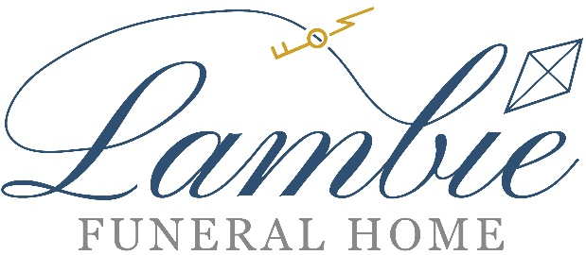
David R. Lambie, F. D., Supervisor & Dana A. Lambie F.D.
8000 Rowland Avenue
Philadelphia, PA 19136
215-332-6110
Family owned and operated since 1949

VETERAN PREARRANGE BURIAL PACKAGE
INCLUDES FREE CASKET
These prices are effective January 1, 2026

The following package is available to a veteran and his or her spouse.
A Valid, Honorably Discharged DD-214 must be presented.

A Note to Families:
Personalization and service are the cornerstone of our philosophy. Dignity and respect are two words we do not take lightly.
We ensure that our families receive the most dignified, state of the art care in a facility that is staffed by caring
professionals at the funeral home and while the burial process is taking place.
Lambie Funeral Home strives to offer the very best care for you and your loved one.

One Day Viewing, Service and Burial ……………………….…… $6,325

Package Includes:
*Transfer of Remains to Funeral Home *Embalming and Other Preparation of the Body
*Basic Services of the Director and Staff *Use of Facilities, Staff, and Equipment for Funeral/Memorial/Rite/Church Service
*Hearse for Transporting Casket *Assistance with Filing of Paperwork Including Life Insurance
*Lead Car / Utility Car *Memorial Thumb Drive
*Online Obituary *Custom Funeral Home Prayer Cards (100)
*Engraving and Embroidery for Casket *Register Book
*Notifying Social Security *Thank You Notes (50)
*Veterans Assistance *24-hour Availability
*Access to Grief Support *Matthews 20 Gauge Baron Casket (Choice of 4 Colors) ($1695 Value)

Burial Vault (if required) and Cash Advances are not included.

Additional Fee for Use of Facilities, Staff and Equipment for Services
on Weekends and Holidays ……………………………………..…………….………. $300
Additional Viewing or Visitation Time…………………..……………additional $200 per hour

Popular Additional Services and Merchandise
Bellia Print and Design Custom Picture Prayer Cards (150) ………………..….…………….….…..…….… $175
Additional Cards (Per 50) ……………………………………………………………………..….………....… $35
Burial Clothing (Suits and Dresses) ……….……………………………………………………... Starting at $200
Limousine……………………………………………………………………………….…..…..……..……… $500
Custom Obituary Programs 100 …………….…………………………………………………..... Starting at $350
Burial Vaults ………………………………………………………………………….………… Starting at $1,195

Please inquire about other ways to remember your loved one such as a bagpiper or a dove release.

The following are the 4 Baron Caskets Included in the Package:

A savings of $1695 for you.

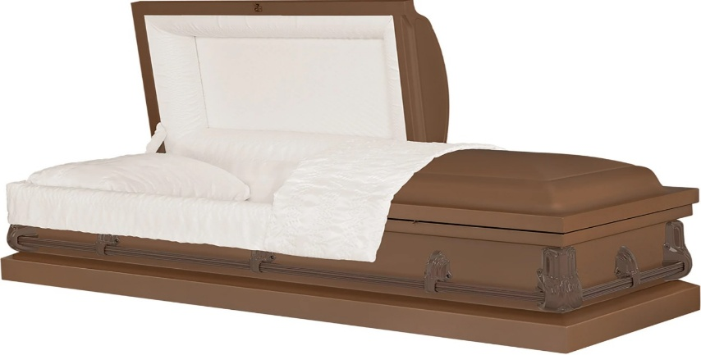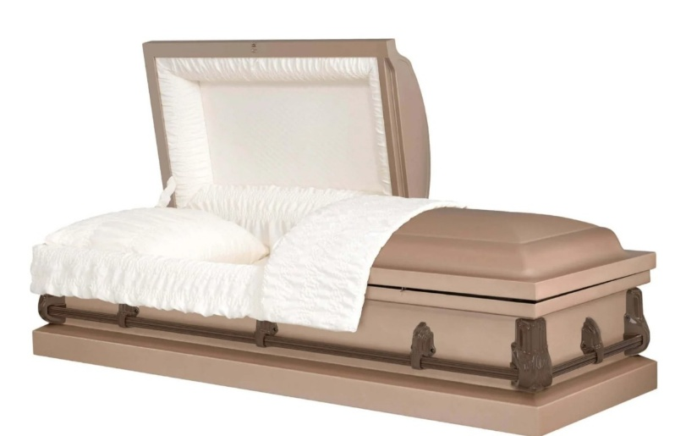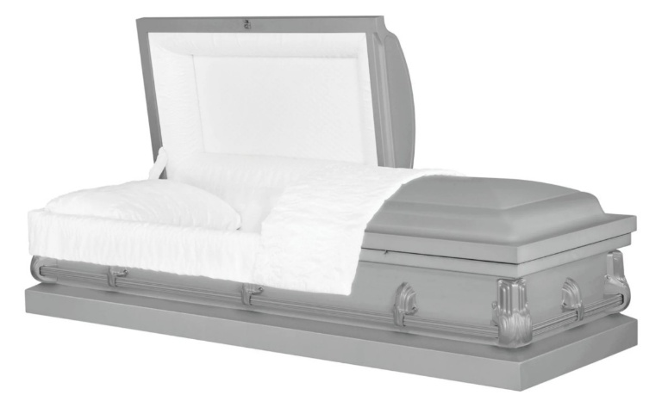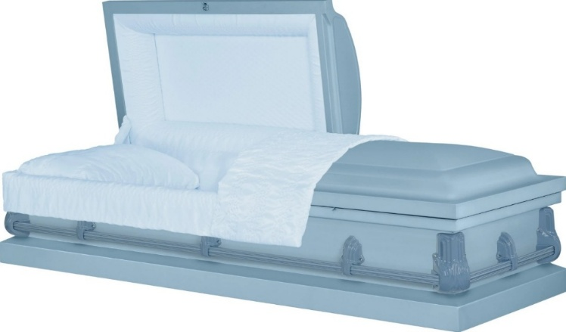

Half Open or Full Open Caskets Available.

All honorably discharged veterans from active-duty service are entitled to burial at a National Cemetery. The Veterans Cemetery Administration will include the grave, the burial vault, the opening and headstone at no charge. This includes the veteran and his or her spouse.

