
David R. Lambie, F. D., Supervisor & Dana A. Lambie F.D.
8000 Rowland Avenue
Philadelphia, PA 19136
215-332-6110
Family owned and operated since 1949

VETERAN PREARRANGE CREMATION PACKAGE
INCLUDES FREE URN
These prices are effective January 1, 2026

The following package is available to a veteran and his or her spouse.
A Valid, Honorably Discharged DD-214 must be presented.

A Note to Families:
Personalization and service are the cornerstone of our philosophy. Dignity and respect are two words we do not take lightly.
We ensure that our families receive the most dignified, state of the art care in a facility that is staffed by caring
professionals at the funeral home and while the burial process is taking place.
Lambie Funeral Home strives to offer the very best care for you and your loved one.

Traditional Cremation …………………………………………….…. $6,400

Traditional Cremation with Viewing before Discount ................................................................. $7,175
Ceremony in our funeral home or a church of choice, one night or day viewing followed by a service.

Package Includes:
*Transfer of Remains to Funeral Home *Embalming and Other Preparation of the Body
*Basic Services of the Director and Staff *Use of Facilities, Staff, and Equipment for Funeral/Memorial/Rite/Church Service
*Hearse for Transporting Casket *Assistance with Filing of Paperwork Including Life Insurance
*Rental Wood Casket *Memorial Thumb Drive
*Cremation Fee *Access to Grief Support
*Cremation Permit *Custom Funeral Home Prayer Cards (100)
*Urn Engraving or Plastic Cremation Urn *Register Book
*Notifying Social Security *Thank You Notes (50)
*Online Obituary *Veterans Assistance
*Urn of your Choice up to $450 Value
Cash Advances are not included.

Memorial Service Cremation ………….…………..……………… $4,300

Memorial Service Cremation with Visitation before Discount .................................................... $4,730
Ceremony in our funeral home or a church of choice, one night or day viewing followed by a service.

Package Includes:
*Transfer of Remains to Funeral Home *Basic Services of the Director and Staff
*Private Family ID (If Permissible*) * Use of Facilities, Staff, and Equipment for Funeral/Memorial/Rite/Church Service
*Cremation Fee *Assistance with Filing of Paperwork Including Life Insurance
*Cremation Permit *Memorial Thumb Drive
*Notifying Social Security *Custom Funeral Home Prayer Cards (100)
*Access to Grief Support *Register Book
*Veteran Assistance *Thank You Notes (50)
*Online Obituary *Urn Engraving or Plastic Cremation Urn
*Urn of your Choice up to $450 Value
Cash Advances are not included.

Direct Cremation ……………………….….………………………..… $2,095

Package Includes:
*Transfer of Remains to Funeral Home *Basic Services of the Director and Staff
*Cremation Fee *Notifying Social Security
*Online Obituary *Assistance with Filing of Paperwork Including Life Insurance
*Access to Grief Support *Plastic Cremation Urn
*Veterans Assistance *Private Family ID (If Permissible*)
Cash Advances and Cremation Permit are not included.

Additional Fee for Use of Facilities, Staff and Equipment
for Services on Weekends and Holidays ……………………………………..……$300
Additional Fee Viewing and Visitation Time………………………………additional $200 per hour

The following Urns are Included in the Package:
A savings of up to $450 for you.

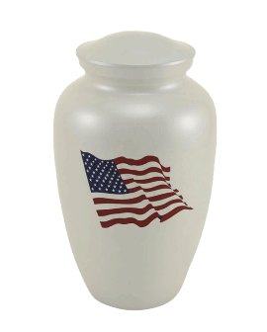
Classic Flag
$450


Kamari Brass
$425


Franklin Cherry
$295
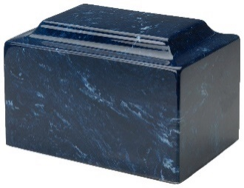

MacKenzie Urns
$425


Marbled Gray
$250

American Flag
$200
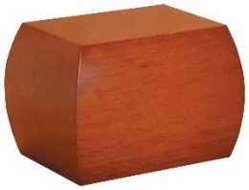

Honey Brown
$295
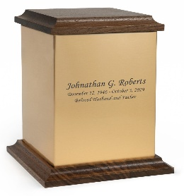
Walnut Sheet
$175

All honorably discharged veterans from active-duty service are entitled to burial at a National Cemetery. The Veterans Cemetery Administration will include the grave, the opening and headstone at no charge. This includes the veteran and their spouse.

